**Dashboard Design**

|  |  |
| --- | --- |
| Date | 19 DEC 2025 |
| Team ID | PNT2025TMIDxxxxxx |
| Project Name | Global Energy Trends: A Comprehensive Analysis of Key Regions and Generation Modes using Power BI |
| Maximum Marks | 5 Marks |

**Global Energy Consumption Trends:**

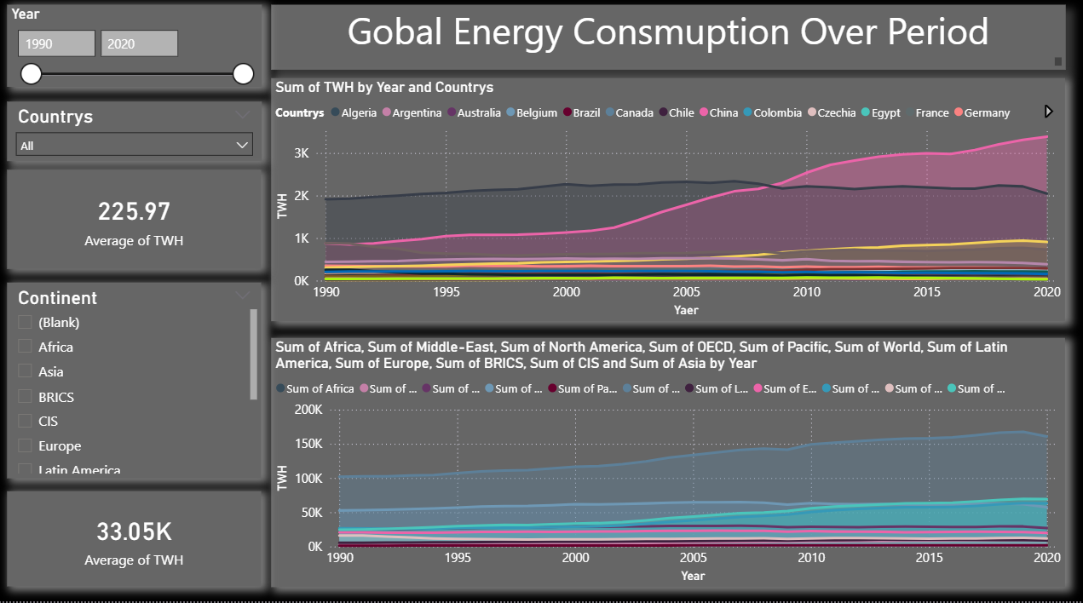

This dashboard shows **global energy consumption trends from 1990 to 2020**. It helps users understand how energy usage has changed over time across **different countries and regions**.

* The **Year slicer** allows users to analyze energy consumption for a selected time period.
* The **Country and Attribute filters** help focus on specific countries, continents, or economic groups such as BRICS, OECD, and CIS.
* The **KPI cards** display the average energy consumption values for quick reference.
* The **top line chart** shows how energy consumption has increased or decreased for individual countries over the years.
* The **bottom chart** compares energy consumption trends across regions and global groups.

Overall, the dashboard provides a **clear and interactive view of global and regional energy consumption patterns**, helping users identify growth trends and high-energy-consuming regions.

**Dash Board 2: Energy Production: Source**

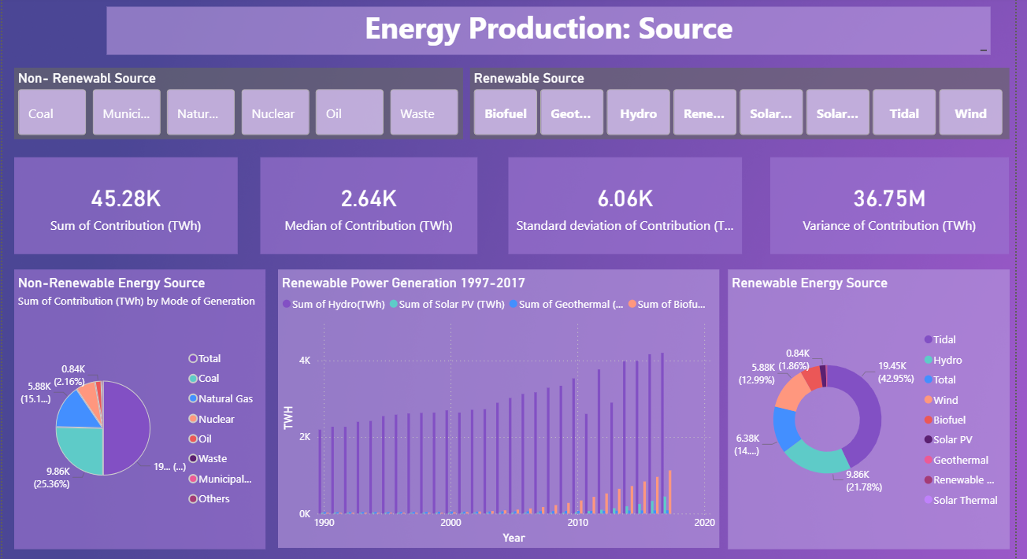

This dashboard explains **energy production by source**, comparing **renewable and non-renewable energy** over time.

* Non-Renewable Source / Renewable Source (Buttons):  
  Used to filter energy production data by specific non-renewable sources (Coal, Oil, Natural Gas, Nuclear, Waste) and renewable sources (Hydro, Solar, Wind, Biofuel, Geothermal, Tidal).
* Sum of Contribution (TWh):  
  Shows the total energy produced from the selected sources in terawatt-hours.
* Median of Contribution (TWh):  
  Displays the middle value of energy contribution, helping understand typical production levels.
* Standard Deviation of Contribution (TWh):  
  Indicates the variation in energy production, showing how much values differ from the average.
* Variance of Contribution (TWh):  
  Represents the spread of energy production data, highlighting fluctuations across sources.
* Non-Renewable Energy Source – Sum of Contribution (TWh) by Mode of Generation:  
  Pie chart showing the distribution of non-renewable energy production across coal, natural gas, nuclear, oil, waste, and municipal sources.
* Renewable Power Generation 1997–2017:  
  Line/column chart showing the growth trend of renewable energy sources such as Hydro, Solar PV, Biofuel, and Geothermal over time.
* Renewable Energy Source:  
  Donut chart displaying the percentage contribution of each renewable source, helping compare their relative importance.

Overall:  
This dashboard clearly summarizes energy production by source, compares renewable and non-renewable contributions, and highlights the rising trend of renewable energy generation.

**Dash Board 3: Power Generation : Top 20 Countries**

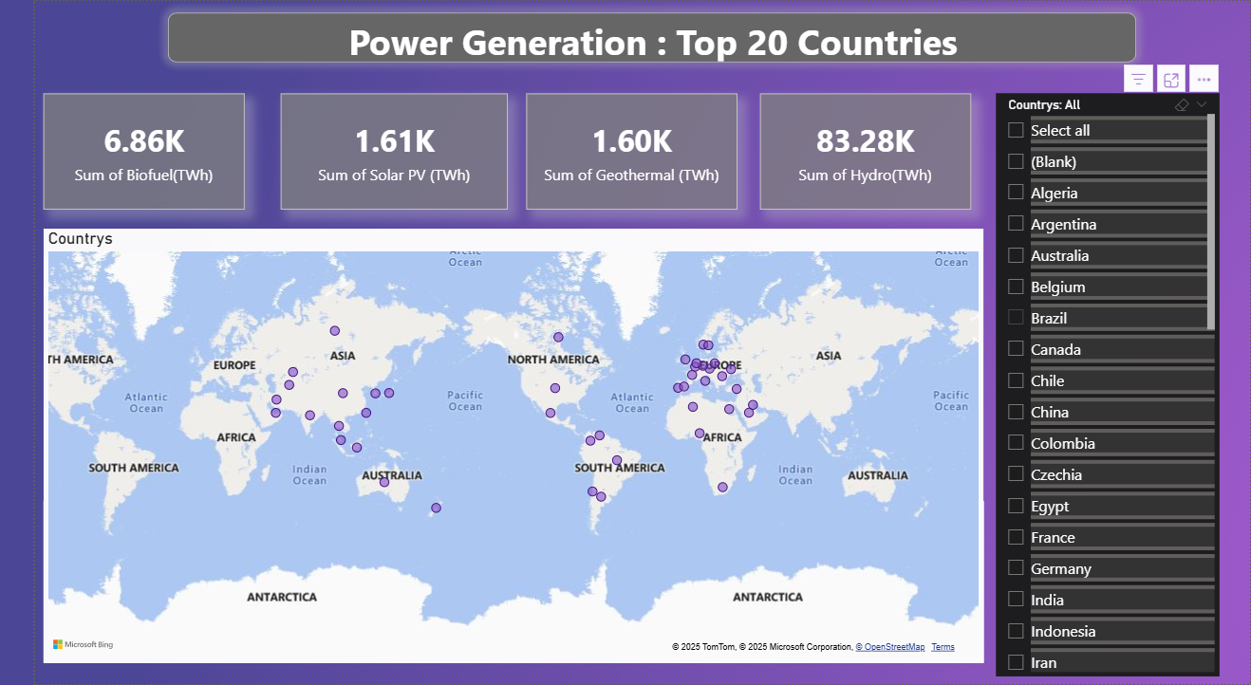

* **Sum of Biofuel (TWh):**  
  Shows the **total biofuel-based power generation** produced by the top 20 countries.
* **Sum of Solar PV (TWh):**  
  Displays the **total electricity generated from solar photovoltaic sources** across the selected countries.
* **Sum of Geothermal (TWh):**  
  Represents the **total power generation from geothermal energy** for the top 20 countries.
* **Sum of Hydro (TWh):**  
  Highlights the **total hydropower generation**, which is the largest contributor among renewable sources.
* **Countries (Map Visual):**  
  World map showing the **geographical distribution of the top 20 power-generating countries**.  
  Each point represents a country’s contribution to renewable power generation.
* **Countries (Slicer):**  
  Allows users to **filter and compare specific countries** from the top 20 list.

**Overall:**  
This dashboard provides a **geographical and quantitative overview of renewable power generation** among the **top 20 countries**, making it easy to identify major contributors and regional distribution patterns.